Background

Qualcomm is requesting to have specific labeling printed out from Exceed for customer Siemens which includes the Siemens customer part number and unique bar coding. This label will need to apply to individual box during shipment. Total of 3 labels per box is needed as per request from Qualcomm.

Objective

To allow Exceed to print out the label specify for shipment to Siemens.

Current Process

None.

Proposed change in outbound Process for Siemens Label printing

Add in the option in Exceed/Hub to allow ops to print out the label.

Others Impact

None

IT TimeLine

Below are the scope and man days for loose carton implementation.

Sno | Description | Man day
1 | Create new program to accept wave key for printing of label | 2
2 | Design, development of label printing program to generate Siemens’s Label | 5
3 | UAT and Signoff by DC | 1
 | Total Man Days | 8

Total IT development cost will be 8 * S$650 = S$5200

Note the cost is based on using current printer.

Sample of proposed Siemens Label;

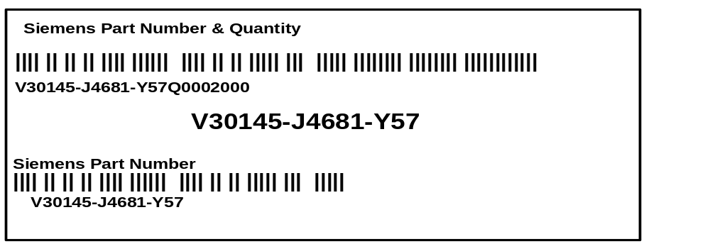
Note : use code39 for the barcode.

The following data elements continue to be printed on the label:
- Item Name (field label “Siemens Part Number & Quantity”)
- Code39 barcode representing ‘CUST PROD ID’ and Reel quantity (separated by the letter ‘Q’ as the data identifier)
- Human readable ‘CUST PROD ID’ and (separated by the letter Q) Quantity in one line.
- Middle of the label to display the customer’s material description (V30145….) in human readable format. This is the Cust PROD ID from above
- Item Name (field label “Siemens Part Number”)
- Code39 barcode representing ‘CUST PROD ID’
- Human readable ‘CUST PROD ID’

